Date: May 29, 2022

speidel-github repository setup-assignment 1_2

Subject: Michele Speidel Module 1_2 GitHub Repository Setup

1. Link to GitHub repository

<https://github.com/jamdmmsfreese/csd-310.git>

1. Screenshot of GitHub repository

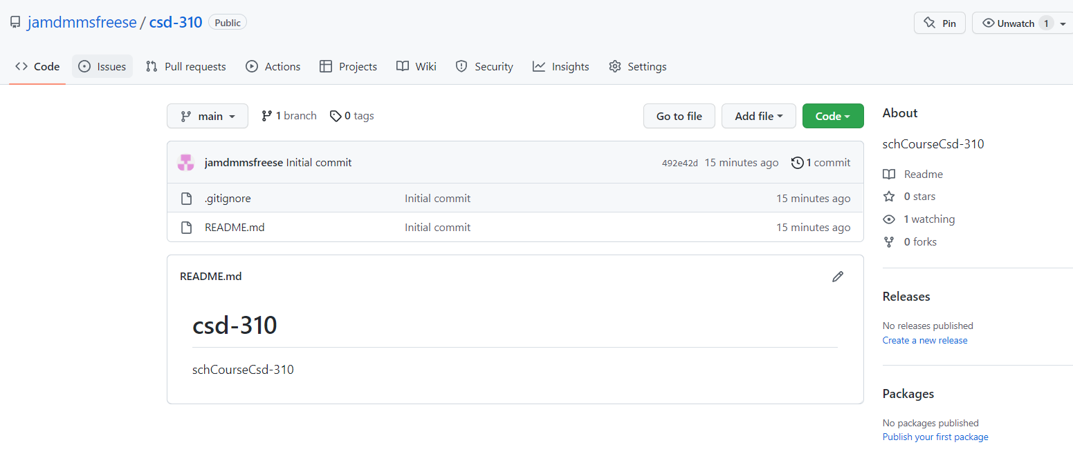

1. Screenshot of local directory

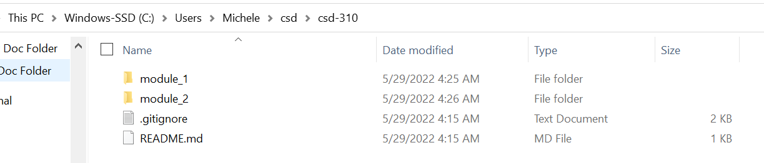

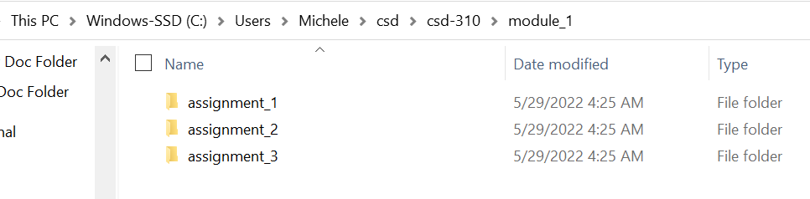

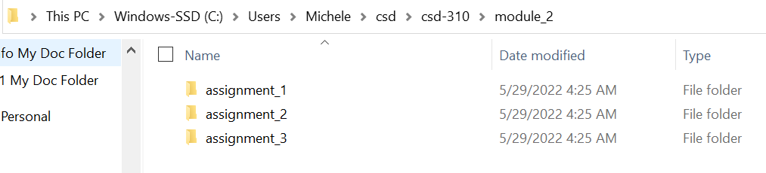

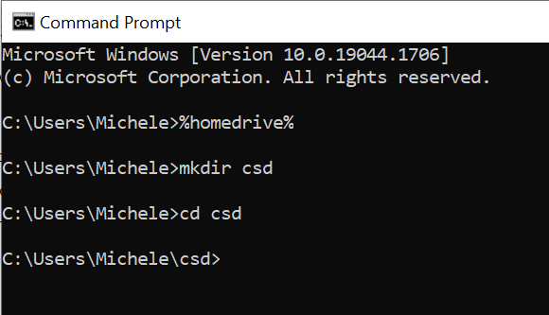

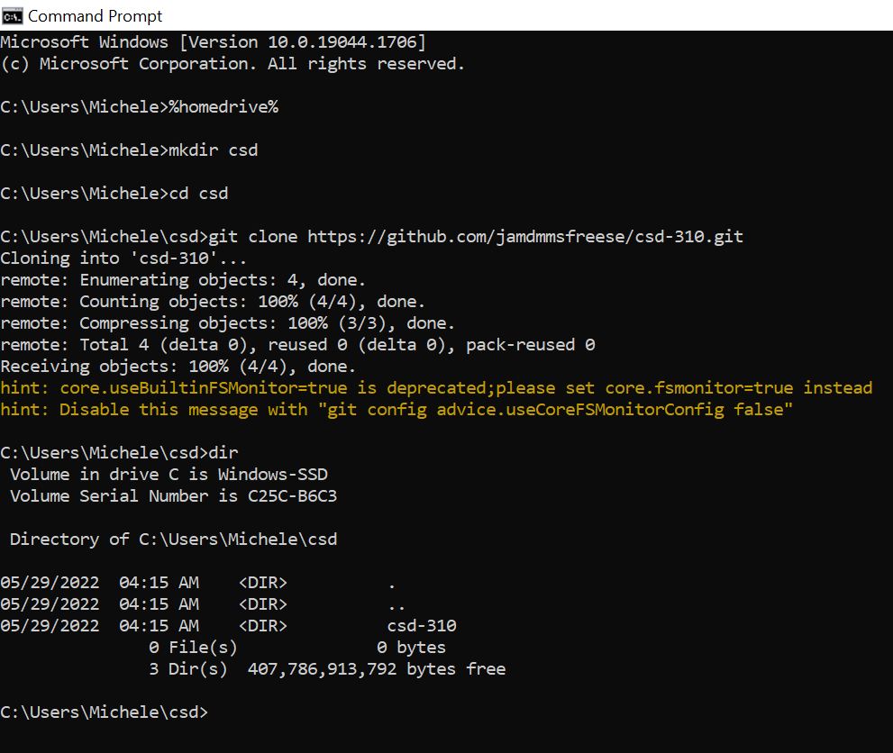

1. Word Document with document name: speidel-github repository setup-assignment 1_2